

**Test: PTM0902**

**Batch: Genesis 9th**

**Sub: Mathematics**

**Time : 90 minutes M. Marks : 40**

1. Prove that area of an equilateral triangle is equal to $\sqrt{\frac{ 3 }{16}}a^{2}$, where a is the side of a triangle. (2)
2. In fig, AOB = 900, AC = BC, OA = 12 cm and OC = 6.6 cm. find the area of ∆AOB.

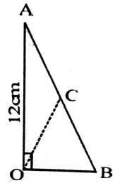 (3)

1. In fig, ABCD is a trapezium in which AB = 7 cm, AD = BC = 5 cm, DC = x cm, and distance between AB and DC is 4 cm. find the value of x and area of trapezium ABCD.

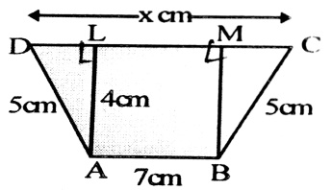 (3)

1. The sides of a triangle are 3cm, 4 cm and 5 cm. The area (in ${cm}^{2}$) of the triangle formed by joining the mid points of this triangle is? (2)
2. The perimeter of a triangle is 30 cm and its area is 30 ${cm}^{2}$. If the largest side measures 13 cm, What is the length of the smallest side of the triangle? (3)
3. From a point of the interior of an equilateral triangle, the length of he perpendiculars to the three sides are 6 cm, 8 cm and 10 cm respectively. The area of the triangle is (3)
4. P and Q are any two points lying on the sides DC and AD respectivley of a parallelogram ABCD. Show that ar ($∆$ APB) = ar ($∆$ BQC). (2)
5. ABCD is parallelogram and O is any point in its interior. Prove that: (3)
6. ar ($∆$ AOB) + ar($∆$ COD) = ar ($∆$ BOC) + ar ($∆$ AOD)
7. ar ($∆$ AOB) + ar $∆$ (COD) = $\frac{1}{2}$ ar $\left({||}^{gm}ABCD\right)$
8. XY is a line parallel to side BC of $∆$ ABC. BE ||AC and CF || AB meet XY in E and F respectively. Show that ar ( $∆$ ABE) = ar = ( $∆$ ACF). (2)

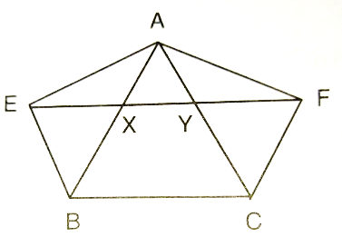

1. In Fig. 14.83, CD || AE and CY || BA. (3)
2. Name a triangle equal in area of $∆$ CBX
3. Prove that ar ( $∆$ ZDE) = ar ( $∆$ CZA)
4. Prove that ar (BCZY) = ar ( $∆$ EDZ).

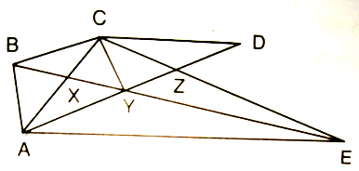 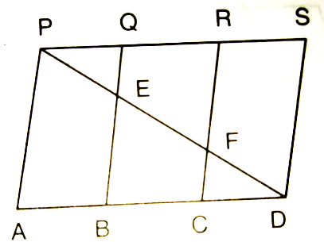

1. D is the mid – point of side BC of $∆$ ABC and E is the mid – point of BD. If O is the mid point of AE, prove that ar ( $∆$ BOE) = $\frac{1}{8}$ ar ( $∆$ ABC). (2)
2. In Fig. 17.20, ABCD is a field in the form of a quadrilateral whose sides are indicated in the figure. If <DAB = 90 $°$, find the area of the field. (3)

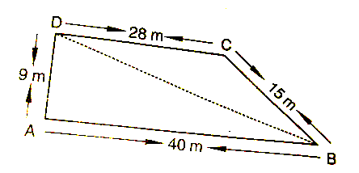

1. A field is in the shape of a trapezium whose parallel sides are 25 m and 10 m. The non – parallel sides are 14 m and 13 m. Find the area of the field. (3)
2. Kamla has a triangular field with sides 240 m, 200 m, 360 m, where she grew wheat. In another triangular field with sides 240 m, 320 m, 400 m adjacent to the previous two parts by field, she wanted to grow potatoes and onions as shown in Fig. 17.24. She divided the field two parts by joining the mid – point of the longest side to the opposite vertex and grew potatoes in one part of onions in the other part. How much area (in hectares) has been used for wheat, potatoes and onions? (1 hectare = 10000 $m^{2}$) (4)
3. A triangle and a parallelogram have the same base and the same area. If the sides of the triangle are 13 cm, 14 cm and 15 cm and the parallelogram stands on the base 14 cm, find the height of the parallelogram. (2)